

School of Computer Science, UPES, Dehradun.

Lab 6.2

DevSecOps Lab

B.TECH. - V Semester

**Submitted to:**

Dr. Hitesh Kumar Sharma

**Submitted by:**

Name: Ishika Mehrotra

Batch: Devops B1

Sap Id: 500124411

Roll No.: R2142230281

**Lab Exercise 6.2**

**Creating a New Jenkins Job to Checkout Source Code**

Steps to be followed:

1. Log in and create a Jenkins job
2. Configure source code management

**Step 1: Log in and create a Jenkins job**

1. Navigate to **localhost:8080** in your web browser, enter your credentials, and click on **Sign In**

1. Create a new Jenkins job by clicking on **New Item**

Provide custom job name inside the field **Enter an item name,** select the **Freestyle project** option,and click on the **OK** button to save the job

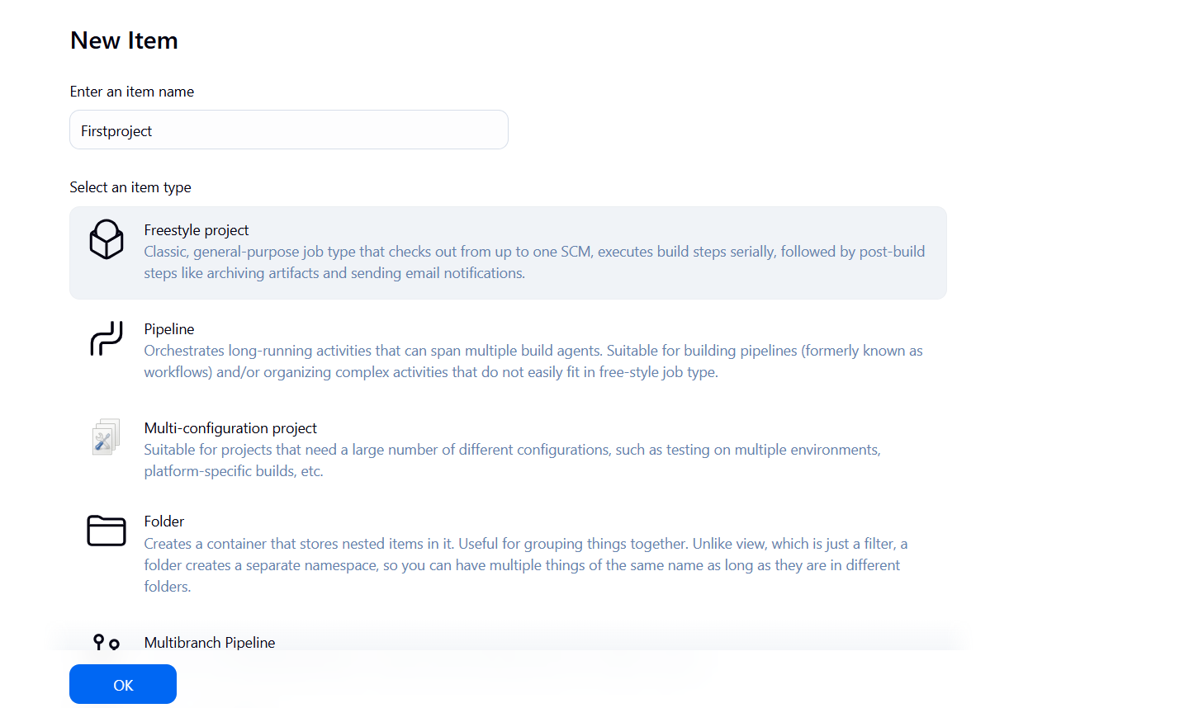

**Step 2: Configure source code management**

1. Access the newly created job's configuration screen by clicking on **Configure**

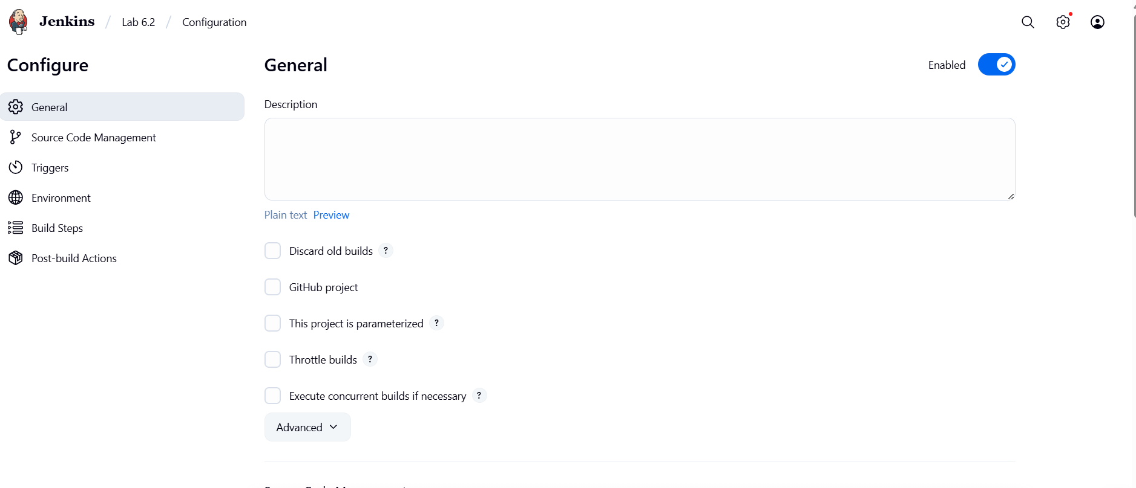

1. Navigate to the **Source Code Management** tab, provide Git repository configuration inside the **Repository URL** field, and click on the **Save** button

2.3 Then, click on the **Build Now** option to schedule a build

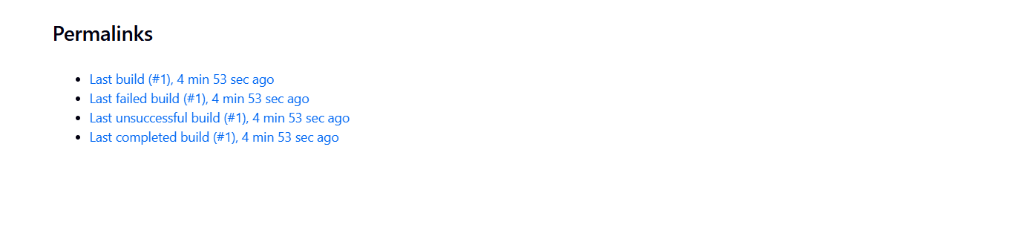

2.4Click on **Console Output** to check out the process during the build process

